

Seneca District Event

# Hosted by Lenape Regional High School District & The Iron Devils (FIRST ROBOTICS TEAM #1647)



**Seneca High School**

110 Carranza Road, Tabernacle, New Jersey 08088

**March 24 – March 26, 2017**

**Team Visitor Information Packet**

**No Smoking on Seneca High School Property**

*Seneca H.S. is a smoke and Tobacco-free site*

**Food and/or drink are allowed ONLY in the Seneca High School Cafeteria**

**Welcome to the MAR Lenape District Event**

**Greetings from the Lenape Regional High School District (LRHSD) and the FIRST Seneca District Event Planning Committee.**

Welcome to the home of the Iron Devils Robotics Team and beautiful Tabernacle, New Jersey!

Looking for a small town that’s scenic and laidback? Then set your compass to green, and you’ll invariably come to Tabernacle, which topped the list of South Jersey Magazine’s Top 10 Small Towns, a subset of the publication’s Top 25 Towns of South Jersey ranking. A farm-community gem that draws folks far and wide for the delicious produce on farm stands and you-pick farms, Tabernacle is one of the reasons you call New Jersey the Garden State. Strawberries in the spring, blueberries and sweet corn in the summer, they’re all hallmarks of the pastoral Burlington County town situated in the core of the Pinelands. The modern-day township, which encompasses just under 50 square miles on the western edge of the Pine Barrens, sprang from the Village of Tabernacle, named for the log-cabin Tabernacle in the Wilderness Church, established in 1778 by Presbyterian minister John Brainerd. Brainerd was a missionary who sought to convert the indigenous Lenni-Lenape Indians to Christianity.

The Lenape District Event Committee welcomes tomorrow’s great thinkers and innovators. Good luck to all participating teams, from near and far. Please use this guide as a reference for our competition; it is full of helpful and useful information that will assist your team as you plan for this event. If you have any questions, please reach out to us using the contact information listing in this brochure.

We welcome you to the Mid Atlantic Robotics Seneca District Event!



**Welcome to Seneca High School**

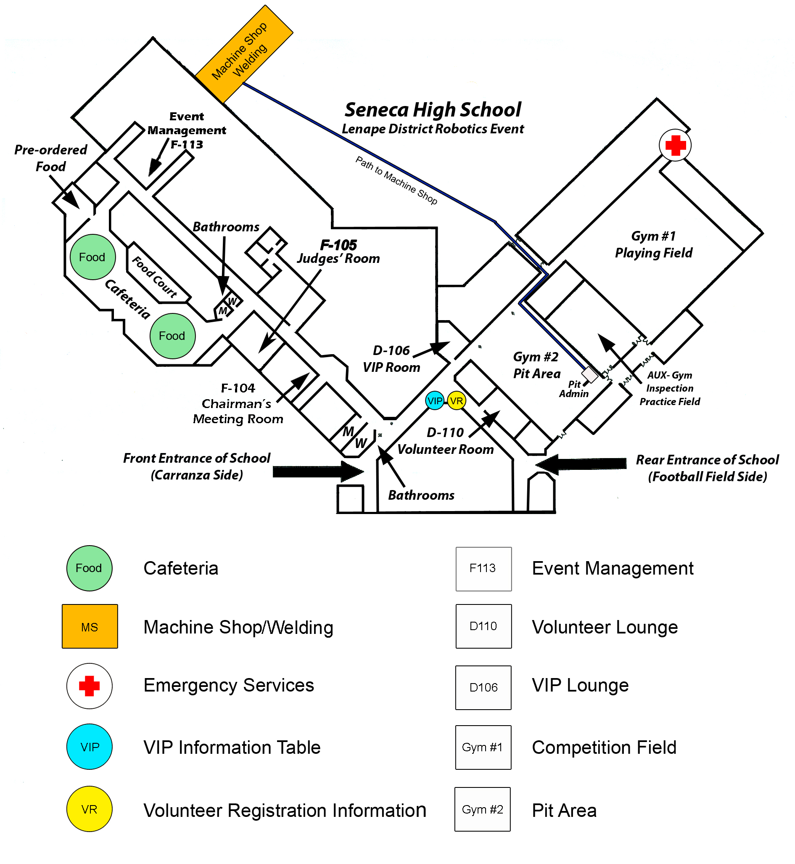

**Getting Around**

# Driving Directions to the Lenape District Event at Seneca High School

Seneca High School is located at 110 Carranza Road, Tabernacle, New Jersey 08088.

## From the North: Exit 7 New Jersey Turnpike Bordentown, NJ

From NJ Turnpike Exit 7-Bordentown, take the first exit onto NJ Route 206 South and follow NJ Route 206 for 18 miles. Continue on NJ Route 206 South (1/2 way round the circle). Continue to 1st traffic light and turn left onto Hawkins Rd. Proceed to the end of Hawkins Rd 2 miles turn right onto Carranza Rd .7 miles school will be on the left.

## From the North: Pa Turnpike to Exit 7 New Jersey Turnpike Bordentown, NJ

Traveling East from the Pennsylvania Turnpike Bridge I-276 (side). Follow the NJ Turnpike to the I-76 North New York Ramp 3.0 miles continue until you come to NJ Turnpike Exit 7-Bordentown 3 miles. Take the first exit onto Route 206 South and follow NJ Route 206 for 18 miles. Continue on NJ Route 206 South (1/2 way round the circle). Continue to 1st traffic light and turn left onto Hawkins Rd. Proceed to the end of Hawkins Rd 2 miles turn right onto Carranza Rd .7 miles school will be on the left.

## From the West: I-95 from Delaware past Phila Airport to the Walt Whitman Bridge

From I-95 North travel from or passing by the Philadelphia Airport Complex. Take Exit 19 for I-76E Packer toward Walt Whitman Bridge. Merge onto I-76 when entering New Jersey. Take Exit 1B to merge onto I-295 North toward Trenton. Traveling 3.9 miles take Exit 34A to merge onto NJ Route 70 E/Marlton East toward Marlton. Travel east on NJ Route 70 for 14 miles. Enter the first roundabout and take 1st exit (right) onto US-206 South. Continue to the 1st traffic light 2 miles and turn left onto Hawkins Rd. Proceed to the end of Hawkins Rd .7 miles turn right onto Carranza Road .7 miles school will be on the left.

## From the West: Philadelphia Ben Franklin Bridge

Traveling East to the entrance of Ben Franklin Bridge, merge onto I-676E US 30 East. Continue to follow 30 E entering New Jersey. Follow I-676 to NJ Route 38 (Find signs for NJ-70E Cherry Hill). Continue on and merge onto NJ Route 70 E Marlton Pike West via ramp to Cherry Hill. Travel east on NJ Route 70 for 18.5 miles. Enter the next roundabout and take 1st exit onto US-206 South. Continue to 1st traffic light and turn left onto Hawkins Rd. Proceed to the end of Hawkins Rd 2 miles turn right onto Carranza Road .7 miles school will be on the left.

## From the West: Betsy Ross Bridge to the Route 70 and 73 Intersection, Marlton, NJ

From I-95 North or South, merge onto NJ Route 90 East. Travel over the Betsy Ross Bridge toward New Jersey. Continue onto NJ Route 70 East for 7.3 miles. Turn left onto NJ Route 73 South and travel 10.2 miles. Enter the next roundabout and take 1st exit onto US-206 South. Continue to 1st traffic light and turn left onto Hawkins Rd. Proceed to the end of Hawkins Rd 2 miles turn right onto Carranza Rd .7 miles school will be on the left.

## From the West: Glassboro or Mullica Hill, NJ

Find and follow Mullica Hill Road US-322 to NJ Route 55 North. Travel 9.6 miles and merge onto NJ Route 42 North. Go 2.1 miles and take Exit 1B to merge onto I-295 North. Continue on for 7.6 miles and take Exit 34A and merge onto NJ Route 70 E Marlton Pike East via ramp to Cherry Hill. Travel east on NJ Route 70 for 14 miles. Enter the next roundabout and take 1st exit onto US-206 South. Continue to 1st traffic light and turn left onto Hawkins Rd. Proceed to the end of Hawkins Rd 2 miles turn right onto Carranza Rd .7 miles school will be on the left.

## From the West: Exit 4 New Jersey Turnpike Mt. Laurel, NJ

From NJ Turnpike Exit 4-Mt. Laurel take the first exit onto NJ Route 70 East South for 3 miles. Then turn left onto NJ Route 73 South and travel 10.2 miles. Travel east of NJ Route 73 for 3 miles. Enter the next roundabout and take 1st exit onto US-206 South. Continue to 1st traffic light and turn left onto Hawkins Rd. Proceed to the end of Hawkins Rd 2 miles turn right onto Carranza Rd .7 miles school will be on the left.

## From the Seacoast (East): Brick Township, Toms River, and Manahawkin

Toms River travel west on NJ Route 37 to the traffic circle take the exit for NJ Route 70 6.7 Miles.

Brick Township travel west on NJ Route 70 to the traffic circle and continue onto NJ Route 70 6 Miles.

Traveling from Manahawkin travel west on NJ Route 72 to the traffic circle and continue onto NJ Route 70 for 15 miles. Follow NJ Route 70 to the traffic circle at US Route 206 7.8 miles from NJ Route 72 and NJ Route 70 intersection. Enter the roundabout and take the 3rd exit onto US-206. Continue to 1st traffic light and turn left onto Hawkins Rd. Proceed to the end of Hawkins Rd 2.0 miles turn right onto Carranza Rd .7 miles school will be on the left.

## From the South: Atlantic City Expressway to Route 54 Hammonton, NJ

Traveling on Atlantic City Expressway (North or South) to Exit 28 to NJ Route 54 Hammonton. NJ Route 54 turns into North 12th Street toward Hammonton/Trenton 3.1 miles. Turn right onto Bellevue Ave., continue onto US-Route 206 North 15.8 miles. Turn right onto Hawkins Rd. Proceed to the end of Hawkins Rd turn right onto Carranza Road. School will be on the left.

**Load-in/Parking at Seneca High School**

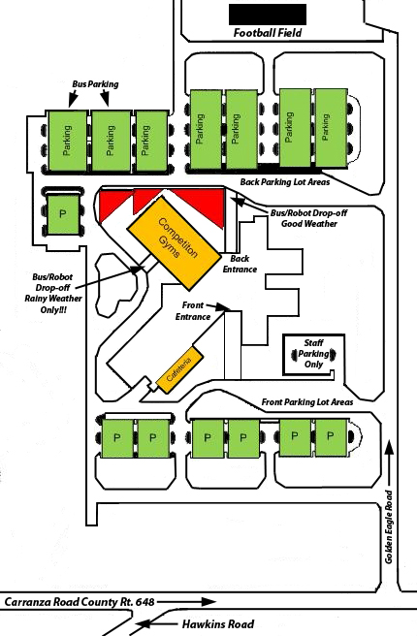

Event Information

# General Event Information

## Consent Forms

FIRST has revised the Consent and Release Form with several goals in mind: 1) simplifying the process by creating a unified form; 2) collecting participant data to make it possible to conduct more effective outreach and marketing to alumni; 3) and give FIRST the capacity to conduct regular follow-up studies of its participants in order to better demonstrate impact. This information is critical to FIRST because it will provide a roadmap for the organization, guide program implementation and management, and communicate more confidently the impact to schools, sponsors and other groups. In order for FIRST to quantitatively state that our programs are positively impacting participating students, corporations, schools and communities we need to collect information on the individual level. The Consent Forms are the only place where FIRST collects that type of information.

The goal of the FIRST Consent Forms is to ensure the following:

* To get consent and release of liabilities due to harm and/or injury for *FIRST* and *FIRST*’s “Cooperating Entities”
* To grant FIRST the right to use participant’s likeness during the participation in FIRST events
* To ensure that agents of *FIRST* and on behalf of *FIRST* can collect and analyze information for us
* To grant *FIRST* the right to contact the Parent/Guardian and participants at a later time for evaluation and/or announce other benefits like alumni outreach efforts

Because we are dealing with youth and youth information, FIRST must be in compliance with the US Children’s Online Privacy Protection Act (under the age 13) and the Canadian Online Protection Act.

*TWO* Consent Forms are required for Registration at This Event:

1. A Team Roster.
2. You must provide the completed 2017 FIRST Consent and Release forms if you did not complete one online. The Mid-Atlantic Robotics event requires an additional 2017 MAR completed release and waiver form for each attending team member and mentor.

For *both* Consent Forms do the following:

* **Put your team number on each of the documents**.
* Make copies of **each** form for each team member.
* Have each person fill out each form.
* Make sure each person under 18 has a legal parent/guardian sign each form.
* Separate the FIRST forms and Mid-Atlantic Robotics forms into two piles and staple the piles.
* Bring both sets to the event registration

## Event Rules

Please read the following restrictions and adhere to them in order to promote an orderly and exciting competition. As a group, we all should honor agreements with the venue and help promote the spirit of good partnership.

* **Please do not attempt to deliver or ship robots directly to the site**. All shipments must go through the drayage company.
* **Please do not remove any FIRST or Team number signs**. This is stealing! Signs are needed for multiple events.
* **Please do not bring food** into the arena.
* **Please do not sell any products**. This includes food, hats, shirts, or any promotional products.
* **Please do not give out any free food products**, such as candy, water, soft drinks, or fruit. You may trade team pins, however. Stickers or Decals are NOT allowed to be distributed as they are often left behind in the venue
* **Please do not sell raffle tickets**.
* **Please do not use extremely noisy devices**, such as floor stompers, whistles, or air horns.
* **Please do not invite or bring live bands** to play in the audience. This dilutes the presentation on the playing field and is too confusing for the audience.
* **Do not play loud music** in the Pit because it interferes with important announcements. If a team is uncooperative, the power to the team's Pit Station will be shut off and/or the music confiscated.
* **Please do not save seats**. It is not fair to other teams or the public that we hope to interest as team sponsors & volunteers.
* **Please do not bring helium tanks**. Helium balloons are NOT allowed at the Arena!
* **Please do not arrange for Internet access** on the site or attempt to connect to the Internet.
* **Please do not use walkie‐talkies** as they interfere with the wireless radios used by event service providers as well as the regional staff
* **Please do not form "tunnels"** during the Awards Ceremony.
* **Please do not run in the venue**.
* **Please do not wear open‐toed or open‐backed shoes in the Pits or on the playing field**. This includes “clog” and “mule” style shoes, such as Crocs.
* **Please ensure anyone in the pit area – including walkways – is wearing safety glasses.**

Finally, please respect the event staff as we are attempting to run a smooth event and keep everyone safe.

## Seating in the Gym

Seating is available on both sides of the field. Please do not block aisles and walkways. There is no assigned seating and seats cannot be saved. Both teams and the general public have access to the seating area throughout the competition. You are responsible for your belongings. No food or drink is permitted in the Seneca Gymnasium during the competition.

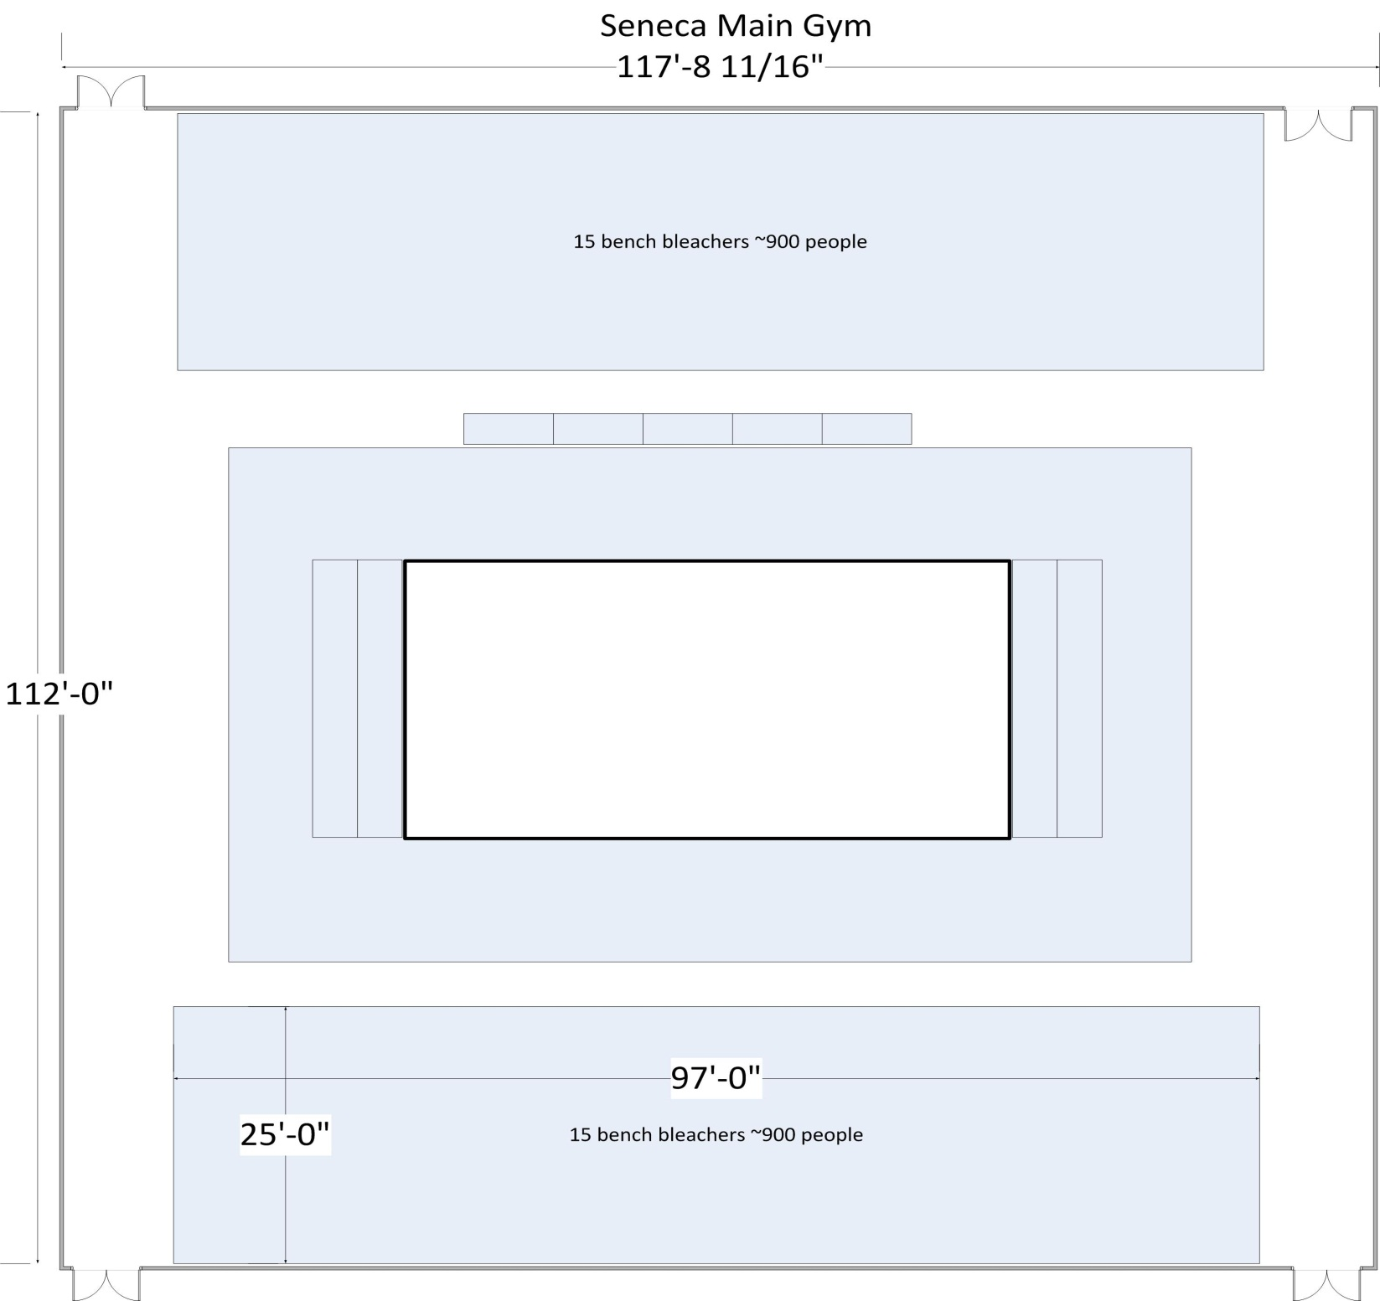

## In Case of Emergency

In the event of an emergency at the Seneca District Event make sure to listen to the instructions from the event staff as it may be necessary to evacuate or clear a path for emergency personnel. We recommend setting up a team meeting place outside of the arena beforehand. A card with this location as well as your hotel and other important team contacts would be a great handout to remind your team! First Aid is located off the rear entry of the main gymnasium away from the direction you enter.

## SAFETY INFORMATION

### Emergency Phone Numbers

* **General Emergency 911**

### Event Phone Numbers

* Kelly Leonard Event Manager 610-999-3848
* Chuck DiVincenzo Event Coordinator 609-969-0135
* Jennifer Enos Event Coordinator 908-462-2794
* Peter Puzio Volunteer Coordinator 609-315-0623

### First Aid

Please go to EMS for first aid treatment. First Aid area will be staffed by EMS personnel on Friday, Saturday, and Sunday. If you need first aid at any other time, please see Pit Administration or one of the Event or Volunteer Coordinators.

### Pit and Competition Field Safety

Safety glasses **must** be worn in the Pits and Competition Fields at all times. Teams and mentors must bring their own safety glasses. Safety glasses will be available for visitor use at the event but must be returned upon leaving the Pit area.

### General Conduct

All participants, volunteers and supporters are expected to exhibit Gracious Professionalism during the entire competition. Any behavior causing safety concerns may result in a warning, or possibly being escorted off the site. Reminder no smoking is permitted on the Seneca High School property and food only in designated areas.

### Safety Questions or Issues

If you need safety information, or encounter unsafe behavior that you are uncomfortable dealing with, please notify the Safety Advisor, Volunteer Coordinator or the Event Manager.

## The Pits

Teams will receive a pit map when they register at the arena on Friday at the Pit Administration Table.

* Each team's pit station will have a table and power outlet. Each pit station will have an 18 amp fuse
* Due to safety and insurance regulations, teams cannot build any structure that supports people or items for storage above the work area in their pit space.
* No structures should be higher than 10 feet above the floor and must safely support any signs or displays mounted to the structure. FIRST will require the removal of any pit structure that is deemed unsafe by event management personnel and local committee members.
* The Team Check list in section 7.16 of the FIRST Robotics Competition Manual has a checklist of items to bring to your pit station

***As a special reminder, don’t forget:***

* A 25 ft. heavy duty extension cord and a power strip
* A small cart to transport your heavy robot from the Pit to the playing field.
* Safety glasses for everyone on your team and your guests if they will be visiting the pits.

**Seneca Gym Pit Diagram - 36 Teams - All pit areas will be 9” x 11”**

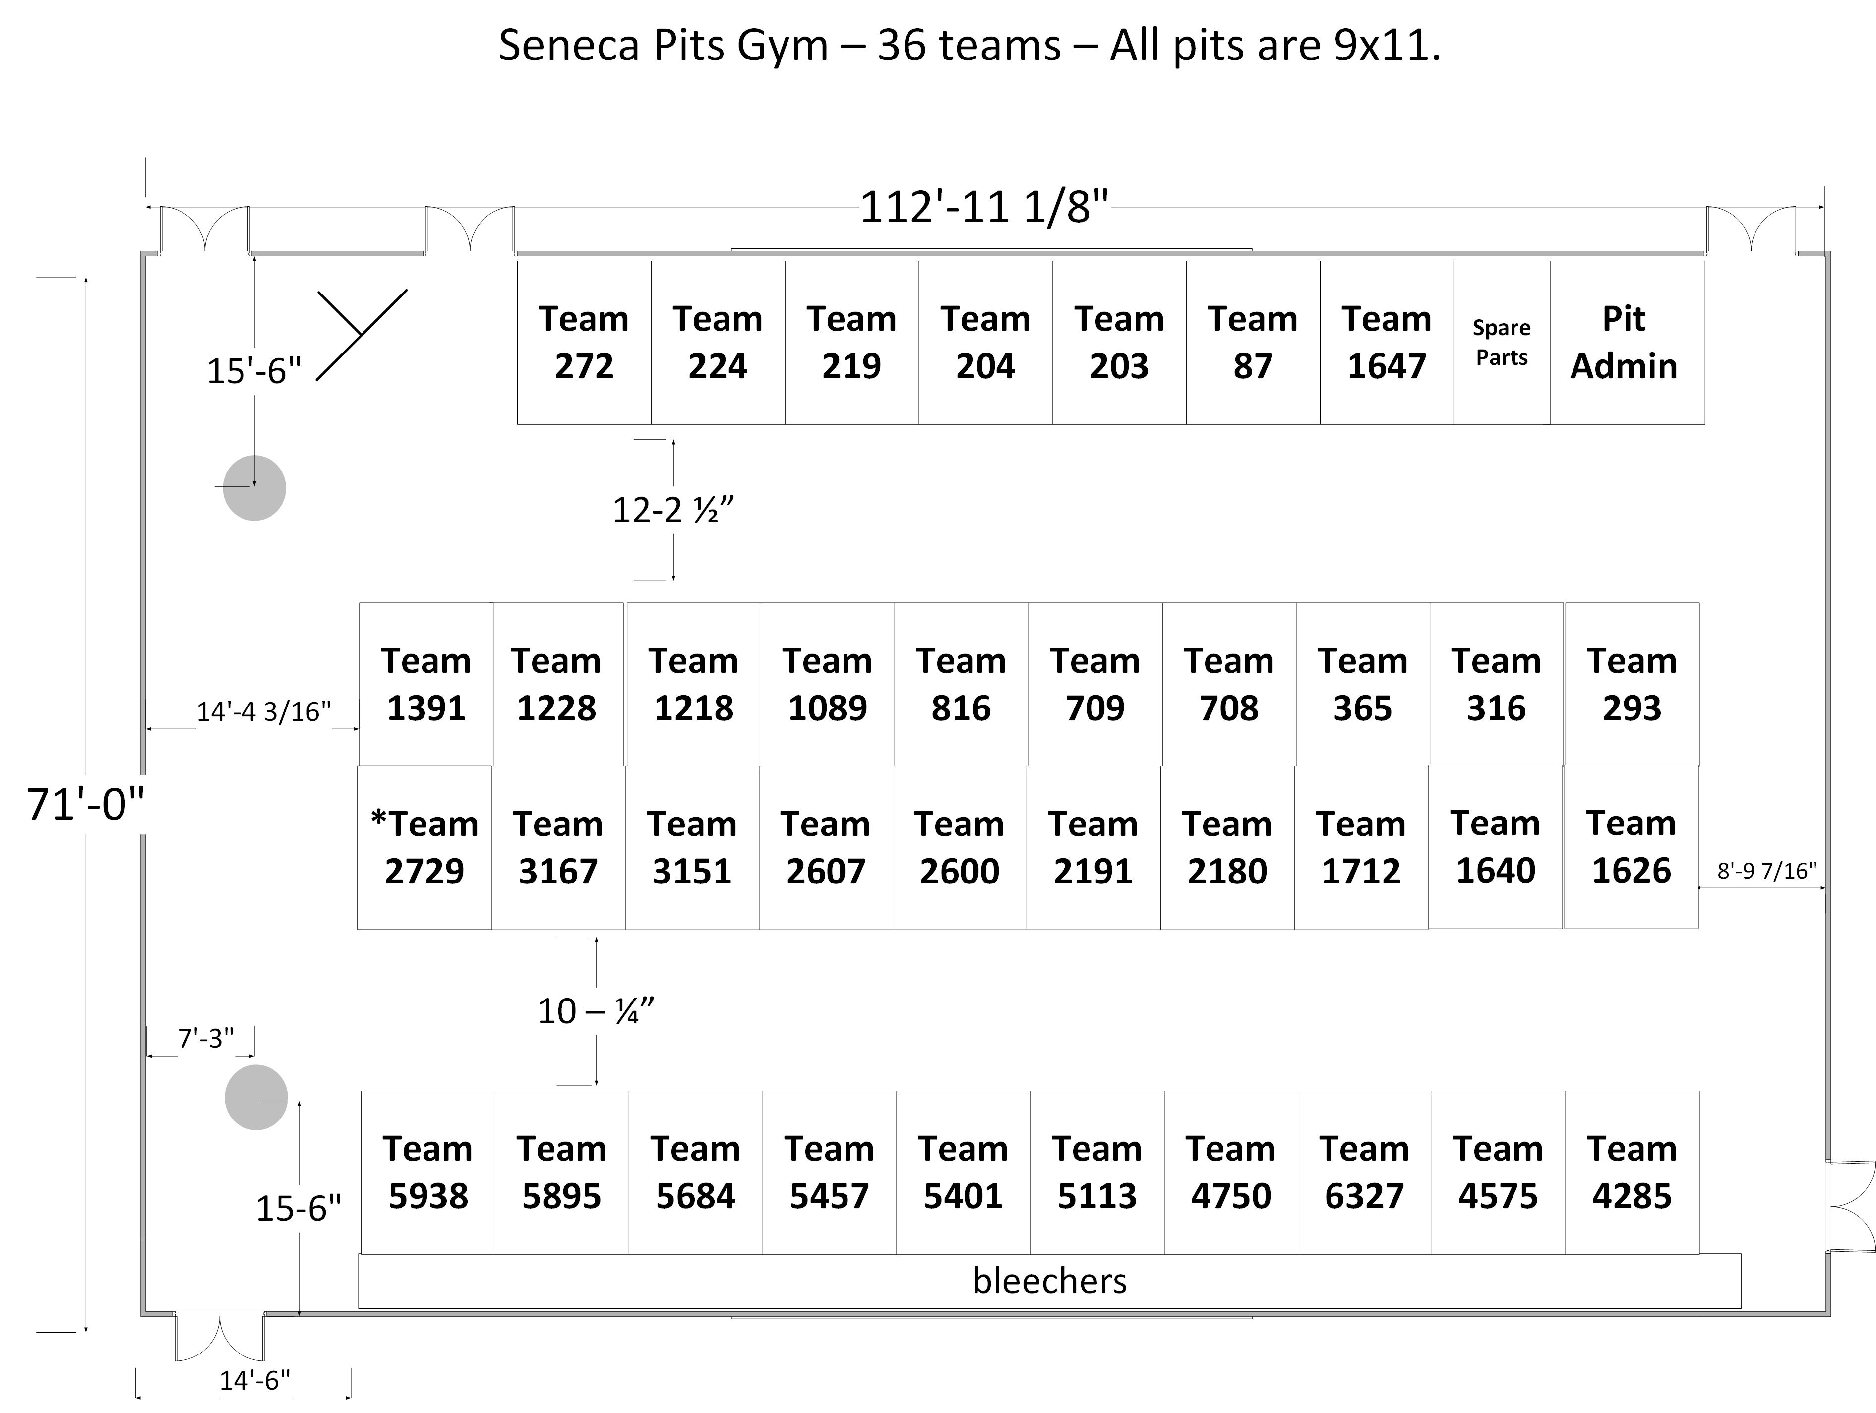

## Machine Shop Information/Rules

* Below are the general rules and process for machine shop work requests:
* You must supply any material that is needed for repairs. The machine shop cannot provide scrap material.
* You may NOT take work requests to the machine shop yourself. All requests must go through Pit Administration.
* One team representative must initially accompany their request to the machine shop, but must leave after providing any needed explanations.
* You may not observe your job being worked due to safety and liability. If you like, you can wait for the part at the Pit Administration Table.
* All work requests are First Come First Serve, unless a reasonable exception can be made. The machine shop cannot guarantee timing for any ASAP requests.
* Once your job is complete, a pit announcement will be made. You may also check back with Pit Administration periodically.

## FOOD/MEALS

Please take advantage of the pre-order meal options for this event since there are not a lot of outside meal options near Seneca High School. Food items will be available for purchase in the Cafeteria Area during the event, which is open to all spectators and teams. Pre-orders offer immediate availability and team time management.

* Pre-order Dinner on Friday, March 24th will be served in the Cafeteria Area starting at 6:30pm.
* Cafeteria Hours from 8:00am – 5:30pm
* Breakfast will be served on both March 25th and 26th in the Cafeteria Area from 8:00am - 10:00am. Available items are: Coffee/Tea; Fruit Juice; Breakfast Sandwiches; Donuts; Muffins; Cookies; Fruit Snacks; Fresh Fruit; and Yogurt.
* Lunch will be served on both March 25th and 26th in the Cafeteria Area from 11:00am - 3:00pm. Available items are Pizza; Sandwiches; Hot Dogs; (Meatball or Sausage n Peppers); Soft Pretzels; Side Toss Salads; Nacho Chips; Soft Pretzels; Candy; Herr’s Chips; Pepsi Drinks; Gatorade; Water; Coffee; Hot Chocolate; Juices; and Tea.
* Lunch Pre-Orders will be available for pick up one half hour prior to break at the designated location. Signs will be posted in the Cafeteria Area.
* Dinner will be served on Saturday March 25th in the Cafeteria Area from 5:00pm - 7:00pm. Available items are Pizza; Pasta, Sandwiches; Hot Dogs; (Meatball or Sausage n Peppers); Soft Pretzels; Side Toss Salads; Nacho Chips; Soft Pretzels; Candy; Herr’s Chips; Pepsi Drinks; Gatorade; Water; Coffee; Hot Chocolate; Juices; and Tea.
* Snacks will be served in the cafeteria throughout the weekend

## Pre-order meal Form



## Event Schedule

### Thursday March 23, 2017

5:00-10:00 pm Field Setup / Volunteer Orientation

### Friday March 24, 2017

4:00 pm Pits Open for Limited Team Members/Team Set-up

6:00 pm Inspection Open/Practice Area Open

6:00-8:30 pm Cafeteria Open for Team Pre-Order Dinner

6:30-9:30 pm Practice Matches (At the discretion of the field staff)

10:00 pm Pits Close / Clean up

### Saturday March 25, 2017

7:15-8:30 am Volunteer Registration/Breakfast

8:00 am Pits Open, Practice Rounds, Inspections, and Machine Shop Open

8:30 am Practice Rounds

10:30 am Opening Ceremonies (Featured Speakers, National Anthem, Game/Scoring Review)

11:00 am Qualifying Rounds

1:00-2:00 pm LUNCH Break

2:00 pm Qualifying Rounds (continued)

7:00 pm Qualifying Rounds end for Day 1

7:30 pm* Pits Close / Clean up

### Sunday March 26, 2017

7:15-8:30 am Volunteer Registration/Breakfast

8:00 am Pits Open and Machine Shop Open

9:00 am Opening Ceremonies (Featured Speakers, National Anthem, Game/Scoring Review)

9:30 am Qualifying Rounds (continued)

12:30 am Alliance Selection

1:00-2:00 pm LUNCH Break for Volunteers

2:00 pm Elimination Rounds Begin

5:00 pm Awards Ceremony

6:30 pm* Pits Close / Clean up

*Schedule subject to change. All times are estimated based on flow of rounds. Pits will close as scheduled or 30 minutes after completion of last match. See Pit Administration table for updated times.

## Teams

87 **Red Devils –** Lockheed Martin/COMCAST-NBC Universal/DoDSTEM/CPS Metals/Rita's Italian Ice/AndyMark/Chick-Fil-A&Rancocas Valley Regional High School, Mt. Holly, NJ

203 **One TUFF Team (Team United for FIRST)** - Campbell's Soup & Camden Co Tech Gloucester, Sicklerville, NJ

204 **Eastern Robotic Vikings** – Eastern Regional High School Board of Education/Eastern Educational Foundation/Lockheed Martin/Renesas & Eastern Camden County Regional High Schools, Voorhees, NJ

219 **Team Impact** - BASF/Picatinny DOTC-Stem & Warren Hills Regional High School, Washington, NJ

224 **The Tribe** - Mars International/ARDEC Picatinny - NDEP /L'Oreal USA/QTS Data Centers/F&A Machine&Piscataway Twp High, Piscataway, NJ

272 **Cyber-Crusaders** - Comcast NBCUniversal/ASI Technologies/SCTE Foundation/Lansdale Cannoneers Sportsman Club /ICON Clinical Research PLC./Rajant Corporation/SolidWorks/Glaxo Smith Kline/Remington & Vernick Engineers&Lansdale Catholic High School 204 Eastern Robotic Vikings, Lansdale, PA

293 **Team S.P.I.K.E.** - Bristol-Myers Squibb / Smith Foundation / Hopewell Valley Education Foundation / Continuum Dynamics / SRI International / Onshape / SolidWorks & Hopewell Valley Central High School, Pennington, NJ

316 **The LuNaTeCs** – DuPont/The Boeing Company/Salem County Community College/Public Service Electric and Gas & South Jersey Robotics, Inc. Carneys Point, NJ

365 **Miracle Workers** – DuPont Engineering/Verizon Foundation/On-Board Engineering/The Boeing Company/Southco/United Therapeutics Corporation/First State Robotics/Verizon Foundation from Wilmington, DE

708 **Hatters Robotics** –Lockheed Martin/Hatboro-Horsham Education Foundation&Hatboro-Horsham Shs, Horsham, PA

709 **Femme Tech Fatale** –The Boeing Company/Glaxo-Smith-Kline&Agnes Irwin School, Bryn Mawr, PA

816 A**nomaly –**Lockheed Martin/Comcast&Inst of Tech Westampton, Westampton, NJ

1089 **Team Mercury** – Bristol Myers-Squibb/East Windsor Regional School District/NDEP/TRUMPF Photonics/Wizcom Corporation/Credit Suisse/J. Rupp Construction/Shiseido/East Windsor Dental Arts/East Windsor Education Association & Hightstown High from Hightstown, NJ

1218 **Vulcan Robotics** –Vulcan Spring/Metal Edge International/Boeing Company/TE Connectivity /Fabspeed Motorsport/ErvTech International/William A. Killian Hardware&Chestnut Hill Academy&Springside School, Philadelphia, PA

1228 **RoboTribe** – NASA/Infineum/A&M Industrial Supply & Rahway High School from Rahway, NJ

1391 **The METAL MOOSE** – IMC Construction/Adaptive Textiles/Tullman Walker Racing/Superion Technology/Arnold Investment Group/The Rue Crew/LoweRiders Bikes & Boards/Sandgate Technologies/PetRad, LLC. & Westtown School, West Chester, PA

1626 **Falcons Robotics** – St. Joseph High School from Metuchen, NJ

1640 **Sab-BOT-age** – The Boeing Company/United Technologies Corporation/Comcast /Chester County Intermediate Unit/Arkema Inc./Herr's Foods/American Society of Mechanical Engineers Philadelphia Chapter & Downingtown Area Robotics, Inc. from Downingtown, PA

1647 **Iron Devils Robotics Team** – Lenape Regional High School District Board of Education/Lockheed Martin/ShopRite of Medford/Shamong Manufacturing Company, Inc./JEMCO Erectors, Inc./PreCast Management/Radwell International, Inc./MTG Services, Inc./Whole Foods/Harriett’s Energy Solutions & Seneca and Shawnee High Schools from Tabernacle, NJ

1712 **Dawgma** - Lockheed Martin/DoD STEM/Leidos/Google/The Wolfson Foundation&Lower Merion Hs, Ardmore, PA

2180 **Zero Gravity** – Geico/Lockheed Martin/BMS/HTEA and NJEA/Johnson & Johnson/NAVAIR*/*Sun Chemical Corporation/NDEP/Mercer County Improvement Authority& Hamilton East-Steinert High School from Hamilton, NJ

2191 **Flux Core (Nottingham H.S. Robotics)** – Nordson Corp./Hamilton Township Education Association (HTEA) & Hamilton North-Nottingham High School from Hamilton, NJ

2600 **Team Falcon** – BAE Systems/Picatinny Arsenal/NDEP-National Defense Education Program/Jefferson Township PBA/Colonial Heating Service/Extreme Abuse Mud Team & Jefferson Township High School from Oak Ridge, NJ

2607 **The Fighting RoboVikings** - Lockheed Martin Corp/Signature Consulting Solutions & Archbishop Wood High School, Warminster, PA

2729 **Storm Robotics Team** – HealthAdvanta/Lockheed Martin/Storm Robotics Parent Club/Vision Edge/ National Defense Education Program/Comcast/CADPRO/Chick-fil-A, Marlton/Pancheros Mexican Grill/Delaware OB/GYN and Infertility Group, P.C./NAVAIR/Miller-Remick LLC/Innovative Software Solutions, Inc./Lenape High School & Cherokee High School from Marlton, NJ

3151 **Cyberstorm** – Castlehale Consulting/Cornell Crane and Steel/United States Navy/Blue Chip Technologies & Gloucester County Institute of Technology from Sewell, NJ

3167 **Mechanical Misfits** –Airline Hydraulics & Father Judge High School from Philadelphia, PA

4285 **Camo-Bots** - Picatinny DoDSTEM/Wayne County Community Foundation/Picatinny Arsenal/Boyce Products Inc/Grimm Construction/The Alpine Meat & Wurst House/Waymart Masonic Lodge/Scarfalloto's Town House Dinner&Honesdale Hs&Western Wayne Hs, Honesdale, PA

4575 **Tin Mints** – COMCAST/BHCU/BOEING/PhillyMade Apparel/The Ridley Township Police Association & Girl Scouts of Eastern PA from Broomall, PA

4750 **BERT** – Cape Bank/Lockheed Martin/TD Bank/Geico/Levi/HFS-Lawfirm/White and Williams Lawfirm/Peter Cordora/Brecoflex Co, LLC/Circuit Tech Assembly and Bishop Eustace Preparatory School from Pennsauken, NJ

5113 **Combustible Lemons** – ASRC Federal Mission Solutions/Comcast NBC Universal/Lockheed Martin/Moorestown Education Foundation/Opex Corporation/Lockheed Martin/OPEX Corporation & Moorestown High School from Moorestown, NJ

5401 **Fightin' Robotic Owls** - The Boeing Company/Pennsylvania Steel/Coren Metal Inc./Village Catering/Old Skillz Graffik Garmentz/Tech Cycle Performance Products&Bensalem Twp Hs, Bensalem, PA

5457 **Falcons** – Robotech Educational Services, Inc. & Burlington Township High School from Burlington, NJ

5684 **Iron Mechs** – Picatinny STEM/Lockheed Martin Corp./ASRC Federal Mission Solutions LLC & Trenton Catholic Academy-Upper School from Hamilton, NJ

5895 **Peddie School Robotics** - Versum Materials/ClearBridge Investments/NASA/Boeing/Allentown Inc/MultiMix/Updata Partners/HSBC&Peddie School, Hightstown, NJ

5938 **Razor Steel Robotics** – NASA/Delaware 4H/Schwan Foods/Century Engineering/Heritage Concrete/Atlantic Tractor/Delaware State University from Dover, DE

6327 **Tin Men** - 4-H of Delaware County/Penn State/The Eastern Pennsylvania Robotics Alliance&Family/Community, Media, PA

# Lodging

* **Comfort Inn & Suites Mt. Laurel-Philadelphia East**

6000 Crawford Place, Mount Laurel, NJ

(856) 727-0010

www.comfortinn.com/hotel-mount_laurel-new_jersey-NJ153

Director of Sales: Jennine Kane (856) 780-1034 [jkane@marshallhotel.com](mailto:jkane@marshallhotel.com)

* **Hampton Inn**

5000 Crawford Place, Mount Laurel, NJ

(856) 778-5535

hamptoninn.com

Sales Manager: Sheri Ceja (856) 996-1424 [scaja@ruchienterprises.com](mailto:scaja@ruchienterprises.com)

* **Wyndham Hotel (**Philadelphia – Mount Laurel)

1111 New Jersey 73, Mount Laurel, NJ

(856) 234-7000

wyndham.com

Sales Manager: Ami Gala (856-234-7009)

* **Aloft**

Mount Laurel

558 Fellowship Road, Mount Laurel, NJ

(856) 234-1880

starwoodhotels.com

Sales Manager: Danette Ridgeway (Extension #2)

* **Candlewood Suites**

4000 Crawford Place, Mount Laurel, NJ

(856) 642-7567

Sales Manager: William Mulvee

* **The Hotel ML**

915 Route 73, Mount Laurel, NJ

(856) 234-7300

thehotelml.com

Sales Manager: John Billetdoux

* **Staybridge Suites Hotel** (Mt. Laurel / Philadelphia)

4115 Church Road, Mount Laurel, NJ

(856) 722-1900

Sales Manager: Katie Miller

* **Hyatt Summerfield Suites**

3000 Crawford Place, Mount Laurel, NJ

(856) 222-1313

summerfieldsuites.hyatt.com

Sales Manager: Lynde Evans (856-581-8348)

* **Courtyard by Marriott** (Mt. Laurel)

1000 Century Parkway, Mount Laurel, NJ

(856) 273-4400

marriott.com

Sales Manager: Tammy Horton (Extension #3)

# Hardware Stores

* **Dubell Lumber**

148 Route 70, Medford NJ 08055

609-654-4143 (Store Hours Friday 7 am-5 pm, Saturday 7 am – 3 pm, Closed Sunday)

* **Lowe’s Mt. Holly Store**

1520 NJ Route 38, Lumberton, NJ 08048

609-518-7680 (Store Hours Friday and Saturday 6am – 9 pm, and Sunday 8 am – 7 pm)

* **Spotts’ Hardware**

646 Stokes Road, Medford NJ 08055

609-654-4464 (Store Hours Friday 8 am-7 pm, Saturday 8 am – 6 pm, and Sunday 9 am – 5 pm)

# Emergency - Hospitals

* **Virtua Marlton**

90 Brick Road, Marlton, NJ 08053

(856) 355-6000

* **Virtua Memorial**

175 Madison Avenue, Mt. Holly, NJ 08060

(609) 914-6000

* **Virtua Voorhees**

100 Bowman Drive, Voorhees, NJ 08043

(856) 247-3000