“Michael Wade” Duel Master Volunteer 2012
Name of person being nominated: Dr. Rich Becker
Nominee Team #: Team 3941 Absolute Zero Electricity
Name of person submitting nomination: Jonathan Ciavolino (jonathanciav@gmail.com)

Michael Wade Award Submission
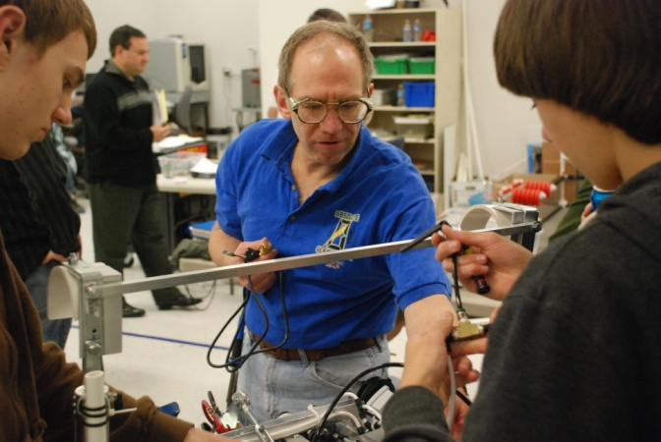
Dr. Rich Becker is a bolt of energy who powers Team 3941. He is an astounding mentor with exactly the right balance of drive and breadth of experience. His involvement with TechBrick began at our open house event in February of 2012. Coach Rich volunteers for the organization Big Brothers/Big Sisters as a "Big Brother", and he brought his young counterpart to the open house to see if he would be interested in a technology-based activity. Although his friend had no interest, Coach Rich was hooked. At the time, Team 3941 was a rookie team and in need of both mentors and team members. Our shooter design for the Rebound Rumble Challenge fascinated him. Noticing we did not calibrate the shooter speed, he saw a way he could help and started by giving us a rotational dynamics lesson during the open house. When he returned the next day, he saw how the team had embraced his lesson, and he has been guiding us ever since!
Since that time, Coach Rich has been the first to arrive and the last to leave each meeting. He guided us in the pits in St. Louis and helped to develop the curriculum for our summer robotics academy. When any student has difficulty solving a problem, Coach Becker uses his experience to enable them to do it themselves, without taking over the project.
From day one of his involvement, Coach Rich has jumped right into "The Vortex" and has risen to the demanding challenges of a mentor. Since joining the team, he has attended virtually every meeting and is always willing to help and teach wherever he can. Sometimes, if there is an unfinished project, he will devote extra time to guide us through its completion. Our CNC is a perfect example; when we first got the CNC machine, he spearheaded the project, inviting students to come in even on off-days to make sure it would be ready for the 2013 season. He has contributed expertise, work, and guidance to all of the systems for this year's robot. He makes sure to send the team and other mentors emails with important updates on the progress of the projects that he oversees. We would definitely not be as far along as we are without him.
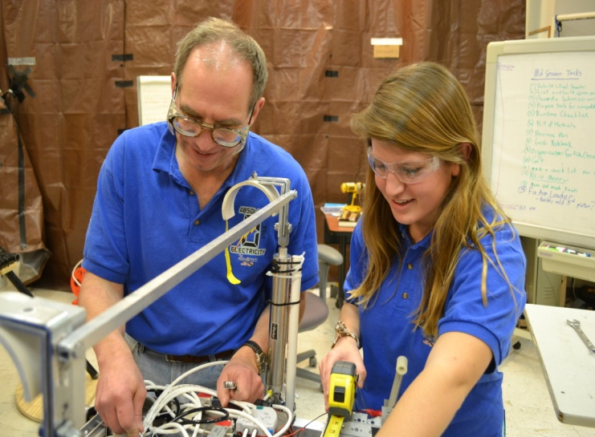
Outside of FIRST, Coach Rich is very involved in the community, especially at his church and with the Big Brothers/Big Sisters program. He is also a world-renowned and published expert on the mechanical behavior of materials. He has worked for Alcoa, Lawrence Livermore National Laboratory, and the Army Research Laboratory.
Coach Rich is kind and helpful to every student. He is a personable coach with a humble character. He is very open to student input and is respected by the entire team. Coach Rich is extremely knowledgeable and loves to share his knowledge with us. He encourages students to excel in every aspect of the design process, from physics, to design, to building, and using various tools and machines. His knowledge and dedication is an inspiration to us all! He is a devoted man, mentor, and friend, and an exceptional candidate for the Michael Wade Award. We are so blessed to call Dr. Rich Becker our mentor.
Welcome to the Vortex, Coach Rich!

